- 1.1 Testing DHCPv4 in Windows - Step 3 - ipconfig/all
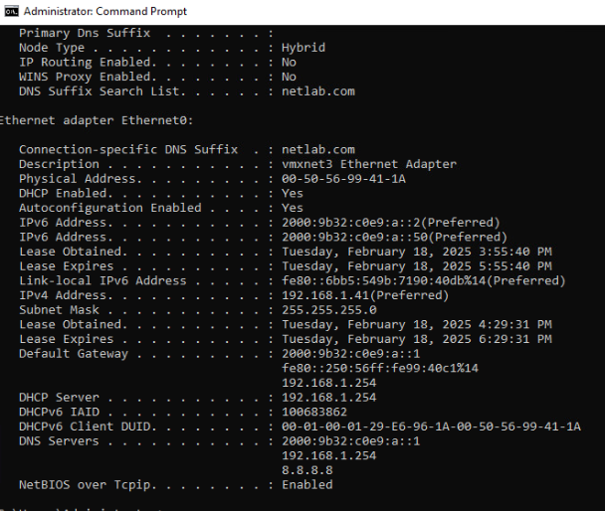

- 3.1 Configure and Verify Static IPv4 addressing in Windows - Step 8 - ipconfig/all
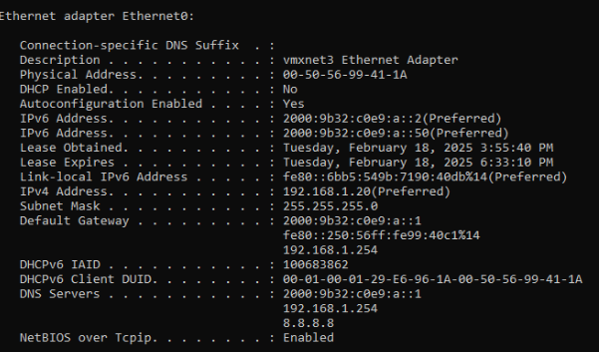
- 3.2 Testing IPv4 Connectivity in Windows - Step 3 - Ping results
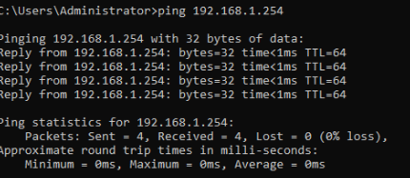

- 4.1 Configure and Verify DHCPv4 Addresses in Linux - Step 12 - ifconfig results
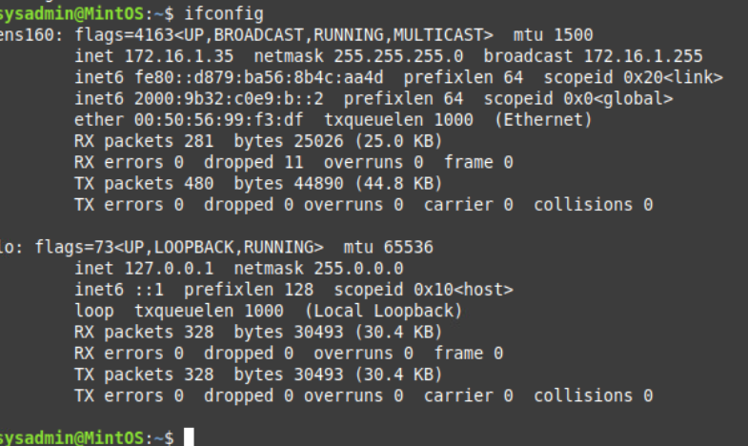
- Step 14, letter j - ip a command results
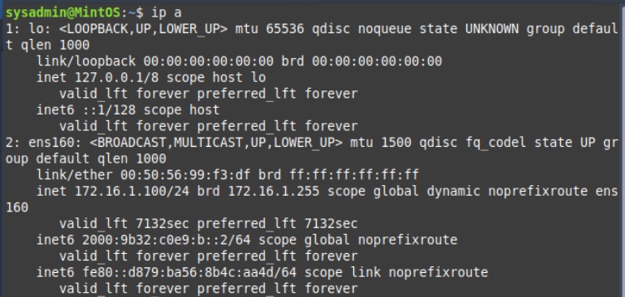

- 5.1 Configure and Verify Static PIv4 addressing in Linux - Step 7 - ip a results
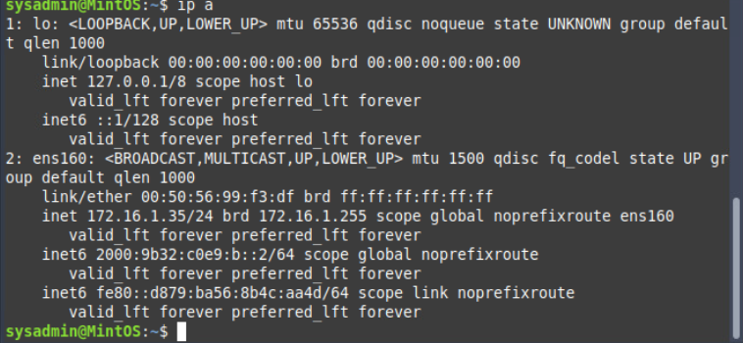
- 5.2 Testing IPv4 Connectivity in Linux - Step 1 - Ping results
